**Vector Calculator**

1. Vector calculator web app has been designed using:

* HTML
* CSS
* Bootstrap
* Java Script and JQuery

2. User will be able to provide the input vector X in three ways as per the specification requirement.

* Vector Values for 'X'
* 3-tuple (Minimum Number, Spacing, Maximum Number)
* 3-tuple (Minimum Number, Spacing, Number of elements)

Basic validations are performed while the data is entered into the input number fields. For instance, only number and other characters will be allowed to enter into these fields. Appropriate messages would be displayed.

When the data is corrected in the input text fields and once the cursor is tabbed out, then the errors will disappear.

3. Formula should be specified by the user. Here an assumption is made that the user should enter the formula only in terms of X.

4. All Math object methods in java script are supported by this application.

5. Once the formula is specified the user can click on “Calculate Result” button and the results would be displayed in a tabular form and graphs. Google graphs have been used to display the results.

Detailed screen shots with screen shots are mentioned for quick reference.

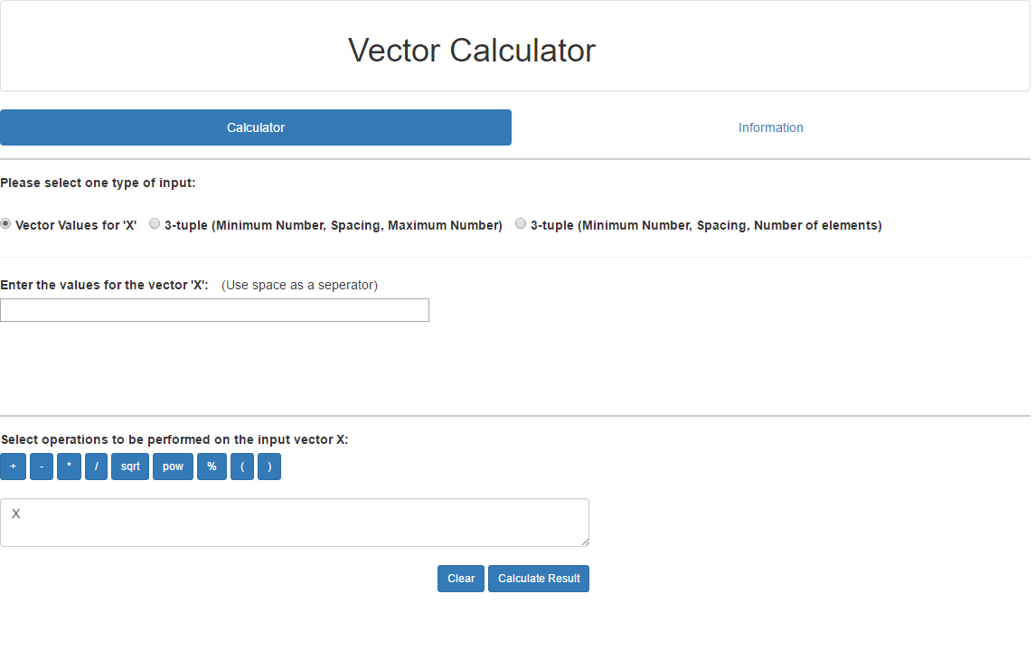

Only Numbers are allowed with spaces

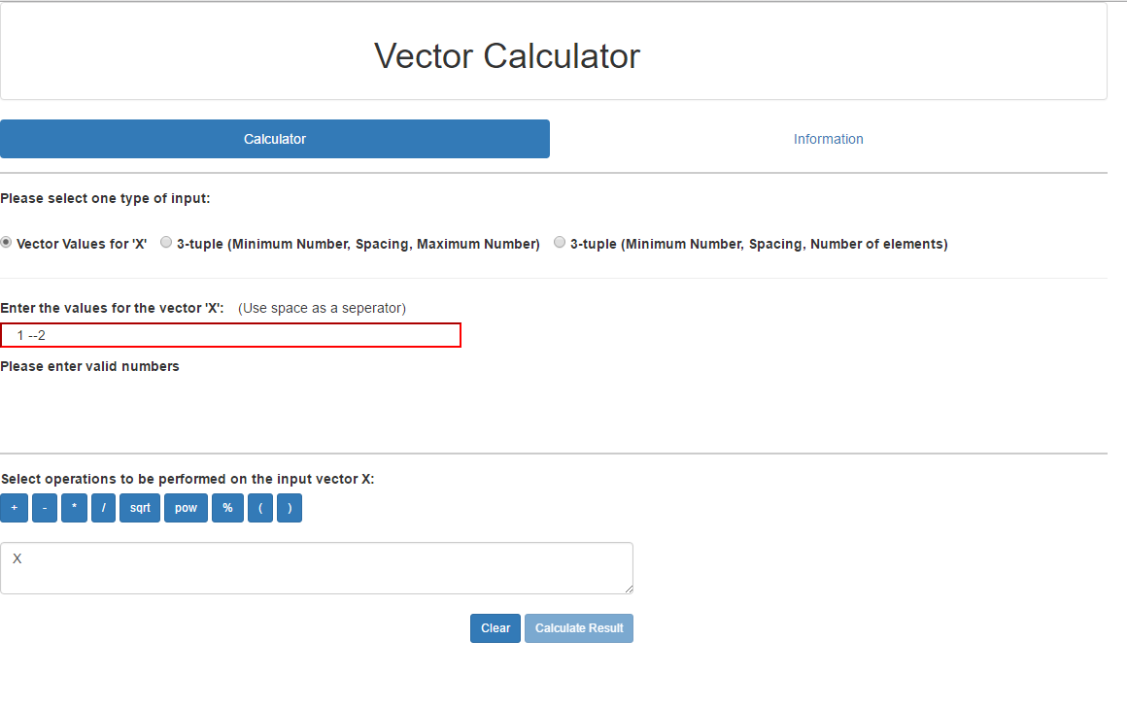

When incorrect data is entered, then the field is highlighted in red and Calculate Result button is disabled.

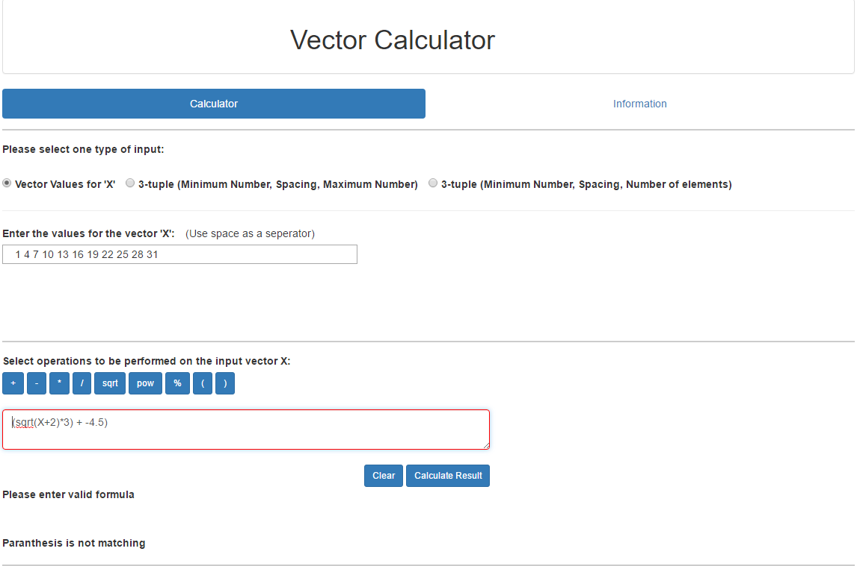

If Parenthesis or formula is entered incorrectly

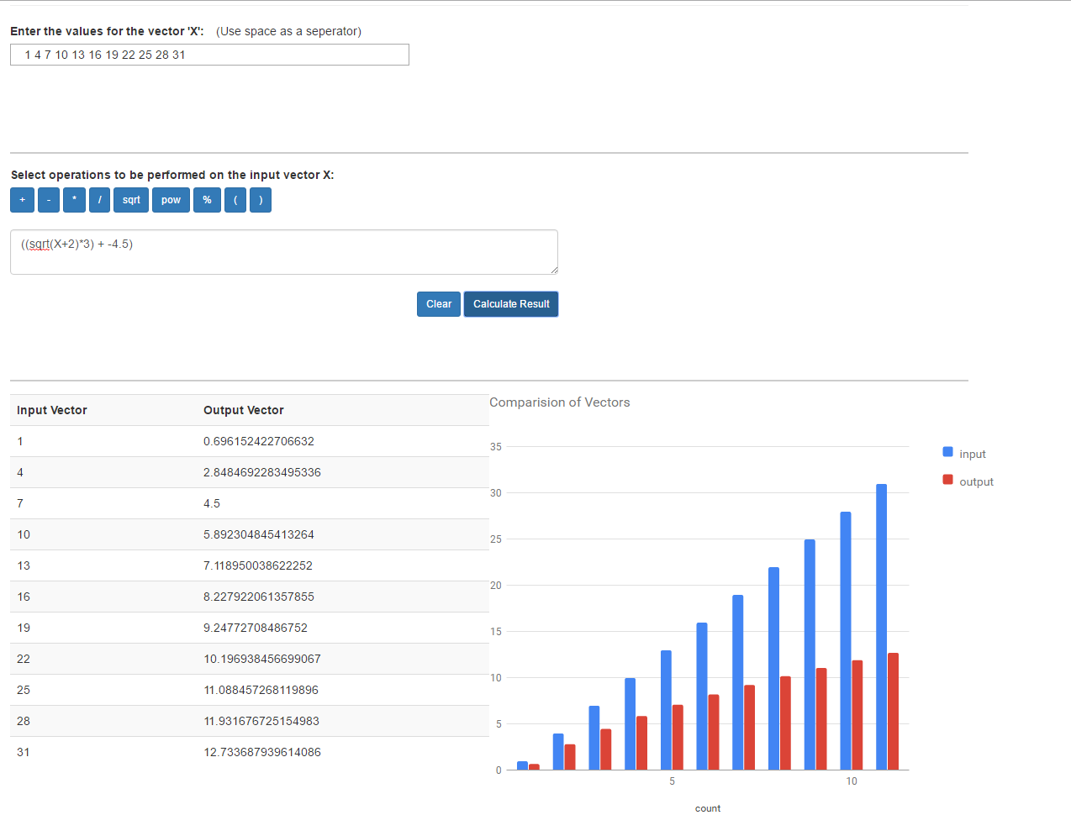

When formula is corrected and calculate result is clicked, the error messages will disappear and results will be displayed in a table and graph